TEAM5OARS

Input Forms and Output Reports

Version 1.0

Signature Block

COSC 4351 | Name Signature | Date
SE Team Leader
SE SQA
SE Team Leader
SE SQA
SE Team Leader
SE SQA
Example Actor: Guest
1. Search Testimonials: A guest is able to search through testimonials at their leisure. Once entering the site they will be presented with a button they must press to see available testimonials. After pressing the button the guest will see a table full of testimonials sorted by date.

Input Form:

Testimonials

Search
love

Output Report:
Testimonial | Date
I love this site!! | 03-March-2013
I love to shop here. | 07-April-2014

TENANT

Input:
Enter Your RENTAL_ID
Look Up
12345

Output:
Pay Rent
Enter a Complaint
Enter a Testimonial

Input:
Pay Rent
Enter a Complaint
Enter a Testimonial

Output:
Rental Number | XXXXXX
Card Details | - Visa  - MasterCard  - Discover
Card Number | XXXXXXXX
Expiration Date | XX/XX/XXXX
Amount Charged | $XXX.XX
Submit

Input:
Enter a Complaint
I Don’t Like this
Submit

Output:
Your complaint is sent

Click to exit

Enter a Testimonial

Input:
Great Project
Submit

Output:
Your testimonial is sent

Click to exit

ASSISTANT

Input:
Enter Your User Name:

Enter Position:

Submit

Output:
Handle New Rentals
Submit
Customer Service
Position:______
Name:______
 | APT No | APT Type | Deposit Amount
 | 1 | xx | 23,234
 | 2 | xx | 12,345
 | 3 | xx | 11,222
 | 4 | xx | 34,221
 | 5 | xx | 100,000
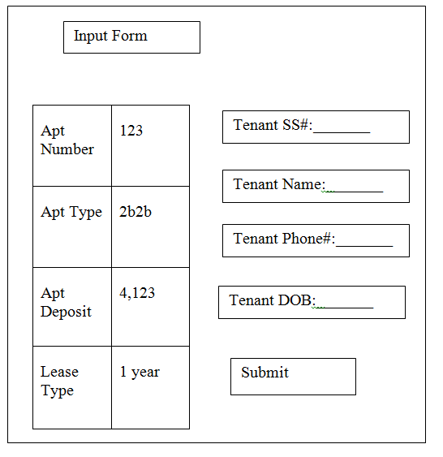

Input:

Output:
Rental Confirmation Details
Rental Number | XXXXXXX
Rental Date | XX/XX/XXXX
Rent Deposit | XXX
Please Deposit Immediately
Thank you

Input:
Customer Service

Tenant List
Apt Payment List

Search Testimonial

Output:

Payment List
Rental No | Invoice# | Invoice Date | Payment Type

Tenant List
SS# | Name | Apt

Input:
Search Testimonials
Like
Search

Output:

Visitor:
Testimonials | Date
I don’t like this | 02/08/2016

Input:
Search Testimonials
Like
Search

Output:

Testimonials | Date
I don’t like this | 02/08/2016

Document Control

Change History

Change History

Table 1: TLs entries (assigned work and due dates) before releasing to the team
Revision | Name | Due Date | Description
1.A | Visak Varghese | 02/10/2016 | Add input and output
1.A | Kaisong Fan | 02/10/2016 | Add input and output
1.A | Keith Russell | 02/10/2016 | Add input and output
1.A | Luis Silva | 02/12/2016 | Review Document

Table 2: Entries when work completed (SVN Commit Comment matches Description)
Revision | Name | Completed Date | Description
1.A |  | XX/XX/XXXX | I finished Tenant & Visitor
1.B |  | XX/XX/XXXX | I …..
1.C |  | XX/XX/XXXX | I …..
1.D |  | XX/XX/XXXX | I …..

Table 3: TL entry for RED DELIVERABLES (SVN Commit Comment matches Description)
Revision | Name | Due Date | Description
2.0 | TL & Name | XX/XX/XXXX | I changed Version to 2.0

Document Storage
This file is stored in SVN at https://svn.cs.uh.edu/svn/cosc4351/team5/TEAM PROJECT DELIVERABLES/Input Forms and Output Reports.doc.

